

**Institute of Computer Technology**

**ACADEMIC PROJECT (3rd Sem.)**

**Subject:- OOP**

**PROJECT NAME:-**

**FileGuard**

**Submitted by:-**

**Vyom Modi**

**En.no:- 23162171009**

**&**

**Divyaraj Parmar**

**En.no:-23162171013**

**Submitted to:-**

**Santanu Sasmal Sir**

**My sql:-**

**Make sql like this.**

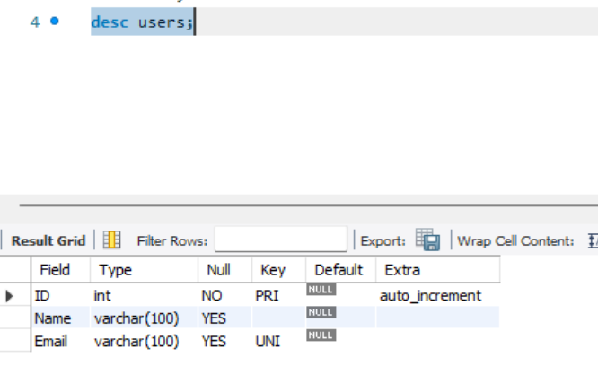 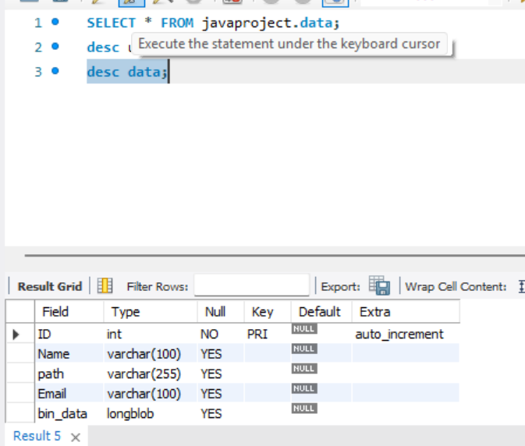

**Mysql:-**

use javaproject;

desc data;

CREATE TABLE data (

    ID INT PRIMARY KEY AUTO_INCREMENT,

    Name VARCHAR(100) NULL,

    path VARCHAR(255) NULL,

    Email VARCHAR(100) NULL,

    bin_data LONGBLOB NULL,

);

desc users;

CREATE TABLE users (

    ID INT PRIMARY KEY AUTO_INCREMENT,

    Name VARCHAR(100) NULL,

    Email VARCHAR(100) NULL UNIQUE,

);

**DB Package**

**SqlConnection.java**

package DB;

import java.sql.Connection;

import java.sql.DriverManager;

import java.sql.SQLException;

public class SqlConnection {

public static Connection *connection*;

public static Connection getConnection() {

try {

Class.*forName*("com.mysql.cj.jdbc.Driver");

*connection* = DriverManager.*getConnection*("jdbc:mysql://localhost:3306/JavaProject?useSSL=false", "root", "your_pass"); // change your password. here

System.***out***.println("Connected Succesfully.");

} catch (ClassNotFoundException | SQLException e) {

e.printStackTrace();

}

return *connection*;

}

public static void closeConnection() {

if (*connection* != null) {

try {

*connection*.close();

} catch (SQLException e) {

e.printStackTrace();

}

}

}

}

**Purpose:**

* **getConnection()**: Establishes a connection to the MySQL database using the provided JDBC URL, username, and password.
* **closeConnection()**: Closes the database connection once it's no longer needed.

**DAO Package**

**UserDAO.java**

package dao;

import java.sql.Connection;

import java.sql.PreparedStatement;

import java.sql.ResultSet;

import java.sql.SQLException;

import DB.SqlConnection;

import Model.User;

public class UserDAO { // DAO Full Form:- Data Access Object

/* isExists(String email):

Purpose: Checks if a user with the specified email exists in the database.

Parameters: String email - the email to be checked.

Returns: boolean - true if the email exists, otherwise false.

*/

public static boolean isExists(String email) throws SQLException {

Connection connection = SqlConnection.*getConnection*();

PreparedStatement ps = connection.prepareStatement("select email from users");

ResultSet rs = ps.executeQuery();

while (rs.next()) {

String e = rs.getString(1);

if (e.equals(email)) {

return true;

}

}

return false;

}

/*

saveUser(User user):

Purpose: Saves a new user to the database.

Parameters: User user - the user object to be saved, containing the user's name and email.

Returns: int - the number of rows affected by the SQL INSERT operation.

*/

public static int saveUser(User user) throws SQLException {

Connection connection = SqlConnection.*getConnection*(); /

PreparedStatement ps = connection.prepareStatement("Insert into users values(default, ?, ?)"); /

ps.setString(1, user.getName());

ps.setString(2, user.getEmail());

return ps.executeUpdate();

}

}

DataDAO.java

package dao;

/* Work of this file

getAllFiles(String email):

This method retrieves all the files from the database based on the provided email. It executes a SQL query and stores the result in a list of Data objects.

hideFile(Data file):

This method hides a file by inserting it into the database. It stores the file’s binary data (bin_data) in the database and then deletes the file from the file system to "hide" it.

unhide(int id):

This method retrieves the file (based on its ID) from the database, writes its binary data back to the file system (restores the file), and then deletes the record from the database, effectively "unhiding" the file.

*/

import java.io.File;

import java.io.FileReader;

import java.io.FileWriter;

import java.io.IOException;

import java.io.Reader;

import java.sql.Clob;

import java.sql.Connection;

import java.sql.PreparedStatement;

import java.sql.ResultSet;

import java.sql.SQLException;

import java.util.ArrayList;

import java.util.List;

import DB.SqlConnection;

import Model.Data;

// getAllFiles function me sari files ko sql me se show kere ge. by email id.

public class DataDAO {

public static List<Data> getAllFiles(String email) throws SQLException {

Connection connection = SqlConnection.*getConnection*();

PreparedStatement ps = connection.prepareStatement("Select * from data where email = ?"); //insert the sql query

ps.setString(1, email);

ResultSet rs = ps.executeQuery();

List<Data> files = new ArrayList<>();

while (rs.next()) {

int id = rs.getInt(1);

String name = rs.getString(2);

String path = rs.getString(3);

files.add(new Data(id, name, path));

}

return files;

}

// we are using this function for hide the files.

//hum pahele file ko bin_data formate me sql me save kere ge and after vo file system me se delet kere ge.

public static int hideFile(Data file)throws SQLException, IOException {

Connection connection = SqlConnection.*getConnection*();

PreparedStatement ps = connection.prepareStatement("insert into data(name, path, email, bin_data) values(?,?,?,?)");

ps.setString(1, file.getFileName());

ps.setString(2, file.getPath());

ps.setString(3, file.getEmail());

File f = new File(file.getPath());

FileReader fr = new FileReader(f);

ps.setCharacterStream(4, fr, f.length());

int ans = ps.executeUpdate();

fr.close();

if (f.exists()) {

System.***out***.println("File exists. Attempting to delete...");

if (f.delete()) {

System.***out***.println("File deleted successfully.");

} else {

System.***out***.println("Failed to delete the file.");

}

} else {

System.***out***.println("File not found.");

}

return ans;

}

// unhide function me hume jo file unhide kerni hee uska path SQL me se milega and after we use FileWriter function and write that file in that location. after that we delet that file data from sql.

public static void unhide(int id) throws SQLException, IOException {

Connection connection = SqlConnection.*getConnection*();

PreparedStatement ps = connection.prepareStatement("select path, bin_data from data where id = ?");

ps.setInt(1, id);

ResultSet rs = ps.executeQuery();

// Check if the result exists

if (rs.next()) {

String path = rs.getString("path");

Clob c = rs.getClob("bin_data");

Reader r = c.getCharacterStream();

try (FileWriter fw = new FileWriter(path)) {

int i;

while ((i = r.read()) != -1) {

fw.write((char) i);

}

}

// Delete the record from the database after successfully un-hiding the file

ps = connection.prepareStatement("delete from data where id = ?");

ps.setInt(1, id);

ps.executeUpdate();

System.***out***.println("Successfully Unhidden");

} else {

System.***out***.println("No file found with the provided ID.");

}

}

}

Model package

Data.java

package Model;

public class Data {

private int id;

private String fileName;

private String path;

private String email;

public Data(int id, String fileName, String path, String email) {

this.id = id;

this.fileName = fileName;

this.path = path;

this.email = email;

}

public Data(int id, String fileName, String path) {

this.id = id;

this.fileName = fileName;

this.path = path;

}

public int getId() {

return id;

}

public void setId(int id) {

this.id = id;

}

public String getFileName() {

return fileName;

}

public void setFileName(String fileName) {

this.fileName = fileName;

}

public String getPath() {

return path;

}

public void setPath(String path) {

this.path = path;

}

public String getEmail() {

return email;

}

public void setEmail(String email) {

this.email = email;

}

}

User.java

package Model;

public class User {

private String name;

private String email;

public User(String name, String email) {

this.name = name;

this.email = email;

}

public String getName() {

return name;

}

public void setName(String name) {

this.name = name;

}

public String getEmail() {

return email;

}

public void setEmail(String email) {

this.email = email;

}

}

Service Package

GenerateOTP.java

package service;

import java.util.Random;

// prepoce:- The GenerateOTP class is designed to generate a 4-digit OTP (One-Time Password) using a random number generator. Here are some improvements and suggestions:

public class GenerateOTP {

public static String getOTP() {

Random random = new Random();

return String.*format*("%04d", random.nextInt(10000)) ;

}

}

SendOTPService.java

package service;

import javax.mail.*;

import javax.mail.internet.InternetAddress;

import javax.mail.internet.MimeMessage;

import java.util.Properties;

public class SendOTPService {

public static void sendOTP(String email, String genOTP) {

// Recipient's email ID needs to be mentioned.

String to = email;

// Sender's email ID needs to be mentioned

String from = "Your_mail@gmail.com"; // Enter your mail address.

// Assuming you are sending email from through gmails smtp

String host = "smtp.gmail.com";

// Get system properties

Properties properties = System.*getProperties*();

// Setup mail server

properties.put("mail.smtp.host", host);

properties.put("mail.smtp.port", "465");

properties.put("mail.smtp.ssl.enable", "true");

properties.put("mail.smtp.auth", "true");

// Get the Session object.// and pass username and password

Session session = Session.*getInstance*(properties, new javax.mail.Authenticator() {

protected PasswordAuthentication getPasswordAuthentication() {

return new PasswordAuthentication(from, "zuim katb omuf qasv");// here Enter Your password or Use a security key

// https://support.google.com/accounts/answer/6103523?hl=en&co=GENIE.Platform%3DAndroid

}

});

// Used to debug SMTP issues

session.setDebug(true);

try {

// Create a default MimeMessage object.

MimeMessage message = new MimeMessage(session);

// Set From: header field of the header.

message.setFrom(new InternetAddress(from));

// Set To: header field of the header.

message.addRecipient(Message.RecipientType.***TO***, new InternetAddress(to));

// Set Subject: header field

message.setSubject("File Enc ka OTP");

// Now set the actual message

message.setText("Your One time Password for File Enc app is " + genOTP);

System.***out***.println("sending...");

// Send message

Transport.*send*(message);

System.***out***.println("Sent message successfully....");

} catch (MessagingException mex) {

mex.printStackTrace();

}

}

}

UserService.java

package service;

import Model.User;

import dao.UserDAO;

public class UserService {

public static Integer saveUser(User user) {

try {

// If the user does not exist, it saves the user data using the UserDAO.saveUser() method.

// If the user already exists, it returns 0 to indicate that saving was skipped.

if (UserDAO.*isExists*(user.getEmail())) { //It checks if a user with the given email already exists in the database using the UserDAO.isExists() method.

return 0;

}else {

return UserDAO.*saveUser*(user);

}

} catch (Exception e) {

e.printStackTrace();

}

return null;

}

}

View Package

UserView.java

package views;

import java.io.File;

import java.io.IOException;

import java.sql.SQLException;

import java.util.List;

import java.util.Scanner;

import Model.Data;

import dao.DataDAO;

public class UserView {

private String email;

UserView(String email){

this.email = email;

}

// The main method to display the user interface and handle user actions

public void home() {

do {

System.***out***.println("Wlcome "+ this.email);

System.***out***.println("Press 1 to show hidden files");

System.***out***.println("Press 2 to hide a new file");

System.***out***.println("Press 3 to unhide a file");

System.***out***.println("Press 0 to exit");

Scanner sc = new Scanner(System.***in***);

int ch = Integer.*parseInt*(sc.nextLine());

switch(ch) {

case 1 : {

try {

List<Data> files = DataDAO.*getAllFiles*(this.email);// Fetch all files for the current user

System.***out***.println("ID - File Name");

for (Data file : files) { // Displaying each file with its ID and name

System.***out***.println(file.getId()+ " - "+ file.getFileName());

}

} catch (SQLException e) {

e.printStackTrace();

}

}

break;

case 2: { // Hide a file

System.***out***.println("Enter the file path:");

String path = sc.nextLine();

System.***out***.println("Path entered: " + path);

File f = new File(path);

if (!f.exists()) { // Check if file exists at the given path

System.***out***.println("File does not exist. Please check the path.");

break;

}

// Create a Data object for the file to be hidden

Data file = new Data(0, f.getName(), path, this.email);

try {

DataDAO.*hideFile*(file); // Call the hideFile method to hide the file

System.***out***.println("File hidden successfully.");

} catch (SQLException | IOException e) {

e.printStackTrace();

}

}

break;

case 3: { // Unhide a file

try {

List<Data> files = DataDAO.*getAllFiles*(this.email);

System.***out***.println("ID - File Name");

for (Data file : files) {

System.***out***.println(file.getId()+ " - "+ file.getFileName());

}

System.***out***.println("Enter the id of file to unhide");

int id = Integer.*parseInt*(sc.nextLine()); // Reading file ID from user

// Check if the entered ID is valid

boolean isVaildID =false;

for (Data file : files) {

if (file.getId() == id) {

isVaildID = true;

break;

}

}

if (isVaildID) {

DataDAO.*unhide*(id); //// Call the unhide method to unhide the file

}else {

System.***out***.println("Wrong ID.");

}

} catch (SQLException e) {

e.printStackTrace();

}catch (IOException e) {

// **TODO**: handle exception

e.printStackTrace();

}

}

break;

case 0: {

System.*exit*(0);

}

}

}while(true);

}

}

Welcome.java

package views;

import java.io.BufferedReader;

import java.io.IOException;

import java.io.InputStreamReader;

import java.sql.SQLException;

import java.util.Scanner;

import Model.User;

import dao.UserDAO;

import service.GenerateOTP;

import service.SendOTPService;

import service.UserService;

public class Welcome {

private static final BufferedReader ***br*** = new BufferedReader(new InputStreamReader(System.***in***));

private static final Scanner ***sc*** = new Scanner(System.***in***);

// This is my welcome screen.

public void welcomeScreen() {

System.***out***.println("Welcome to the app");

System.***out***.println("Press 1 to login.");

System.***out***.println("Press 2 to signup.");

System.***out***.println("Press 0 to exit.");

int choice = 0;

try {

choice = Integer.*parseInt*(***br***.readLine());

switch (choice) {

case 1:

login();

break;

case 2:

signUp();

break;

case 0:

System.*exit*(0);

break;

default:

System.***out***.println("Enter valid input.");

}

} catch (IOException | NumberFormatException e) {

System.***out***.println("Invalid input. Please try again.");

welcomeScreen();

}

}

private void login() {

System.***out***.println("Enter your email:");

String email = ***sc***.nextLine().trim();

try {

if (UserDAO.*isExists*(email)) {

// Generate and send OTP

String genOTP = GenerateOTP.*getOTP*();

SendOTPService.*sendOTP*(email, genOTP);

System.***out***.println("Enter the OTP:");

String otp = ***sc***.nextLine().trim();

if (otp.equals(genOTP)) {

new UserView(email).home();

} else {

System.***out***.println("Wrong OTP.");

}

} else {

System.***out***.println("User not found.");

}

} catch (SQLException e) {

e.printStackTrace();

}

}

private void signUp() {

System.***out***.println("Enter Name:");

String name = ***sc***.nextLine().trim();

System.***out***.println("Enter email:");

String email = ***sc***.nextLine().trim();

try {

if (UserDAO.*isExists*(email)) {

System.***out***.println("Email already exists.");

} else {

String genOTP = GenerateOTP.*getOTP*();

SendOTPService.*sendOTP*(email, genOTP);

System.***out***.println("Enter the OTP:");

String otp = ***sc***.nextLine().trim();

if (otp.equals(genOTP)) {

User user = new User(name, email);

int response = UserService.*saveUser*(user);

switch (response) {

case 0:

System.***out***.println("User already exists.");

break;

case 1:

System.***out***.println("User registered successfully.");

break;

default:

System.***out***.println("An unknown error occurred.");

}

} else {

System.***out***.println("Wrong OTP. Registration failed.");

}

}

} catch (SQLException e) {

e.printStackTrace();

}

}

}

Main.java

import views.Welcome;

public class Main {

public static void main(String[] args) {

Welcome w = new Welcome();

do {

w.welcomeScreen();

} while (true);

}

}

Pom.xml

Dependencies which I am added.

**MySQL Connector/J (JDBC Driver)**

* Purpose:
  + Provides connectivity between the application and a MySQL database.
  + Allows the application to execute SQL queries and interact with the database.

**JavaMail API (Email Services)**

* **Purpose:**
  + Enables the application to send emails using the JavaMail API.
  + Useful for implementing email-based features such as sending OTPs or notifications.

<project xmlns="http://maven.apache.org/POM/4.0.0"

xmlns:xsi="http://www.w3.org/2001/XMLSchema-instance"

xsi:schemaLocation="http://maven.apache.org/POM/4.0.0 http://maven.apache.org/xsd/maven-4.0.0.xsd">

<modelVersion>4.0.0</modelVersion>

<groupId>Email_Authentication</groupId>

<artifactId>EmailAuthentication</artifactId>

<version>0.0.1-SNAPSHOT</version>

<packaging>jar</packaging>

<name>EmailAuthentication</name>

<url>http://maven.apache.org</url>

<properties>

<project.build.sourceEncoding>UTF-8</project.build.sourceEncoding>

</properties>

<dependencies>

<dependency>

<groupId>junit</groupId>

<artifactId>junit</artifactId>

<version>3.8.1</version>

<scope>test</scope>

</dependency>

<!-- https://mvnrepository.com/artifact/mysql/mysql-connector-java -->

<dependency>

<groupId>mysql</groupId>

<artifactId>mysql-connector-java</artifactId>

<version>8.0.33</version>

</dependency>

<!-- https://mvnrepository.com/artifact/javax.mail/javax.mail-api -->

<dependency>

<groupId>com.sun.mail</groupId>

<artifactId>javax.mail</artifactId>

<version>1.6.2</version>

</dependency>

</dependencies>

</project>

Outputs:-



